**Literals**

Any constant value which can be assigned to the varaiable is called a literal.

For eg int x =10;

Int -> Data type

X -> Name of variable or identifier

10 -> constant value or literal

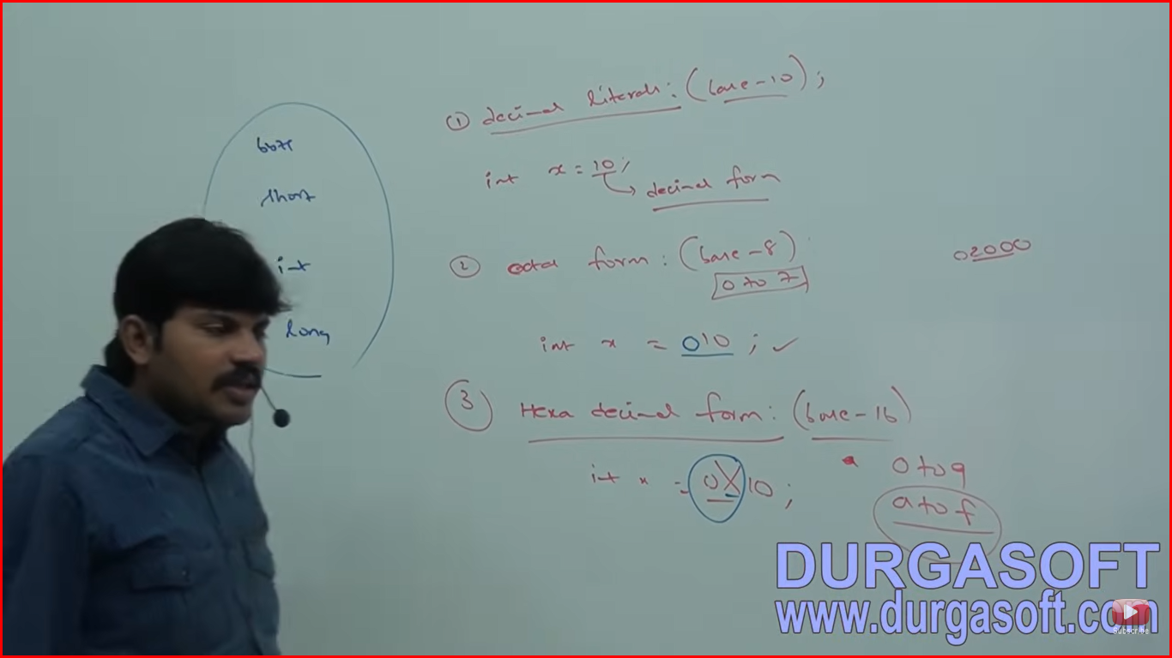

**Integral Literals**

For Integral data types (byte, short, int, long) we can specify literal values in the following ways:

1. **Decimal Literals (Base 10)**

Allowed digits are 0 to 9. Eg. int x = 10;

1. **Octal Form (Base 8)**

Allowed digits are 0 to 7. For eg. int x = 010;

Literal value should be prefixed with 0.

1. **Hexadecimal Form (Base 16)**

Allowed digits are 0 to 9 and a to f. For eg int x = 0X10;

For extra digits (a to f) we can use both lower case and upper case characters. This is one of very few areas where Java is not case sensitive.

The literal value should be prefixed with 0x or 0X.

These are only possible values for integral data types.

**int i =10; ///**valid

**//int j = 0786; //**invalid //Exception in thread "main" java.lang.Error: Unresolved compilation problem:

//The literal 0786 of type int is out of range //Because it is octal number as we prefixing with 0 and octal digits are allowed from 0 to 7 only

**int x1 = 0xFace;**//valid

**int x2 = 0xBeef; //**valid

**//int x3 = 0xBeer;** //invalid because r is not allowed

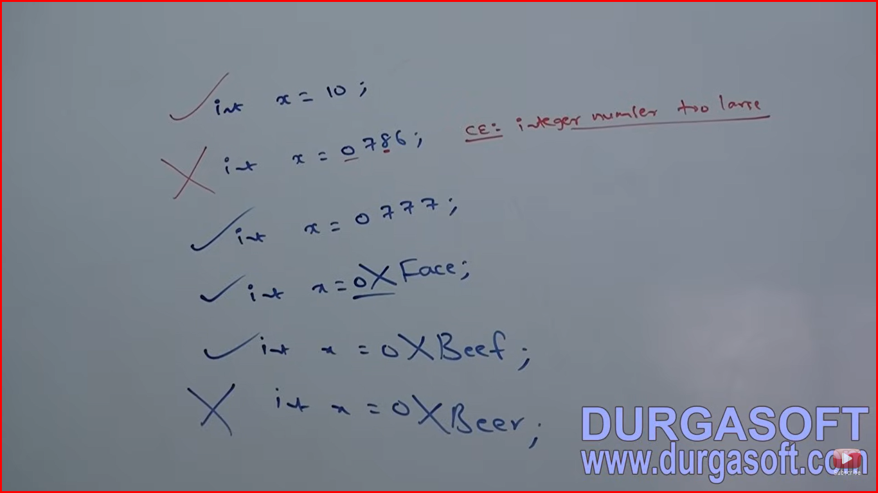

By default every integral literal is of int type but we can specify explicitly as long type by suffixed with small l or capital L.

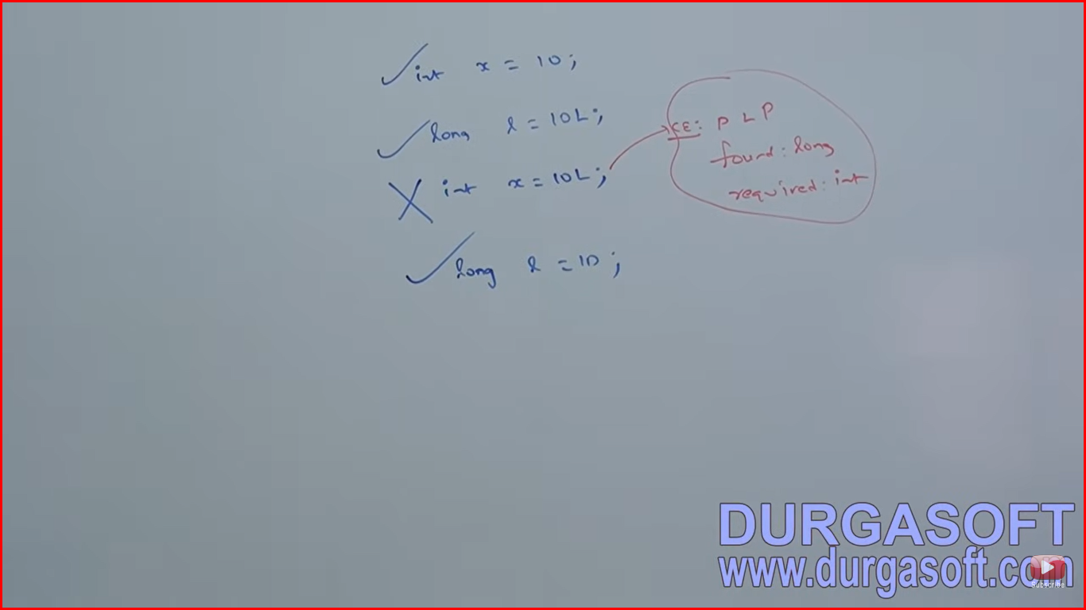

There is no direct way to specify byte or short literal explicitly but indirectly we can specify integral literal to the byte variable and if the value within the range of byte then compiler treats it automatically as byte literal similarly short literal also.

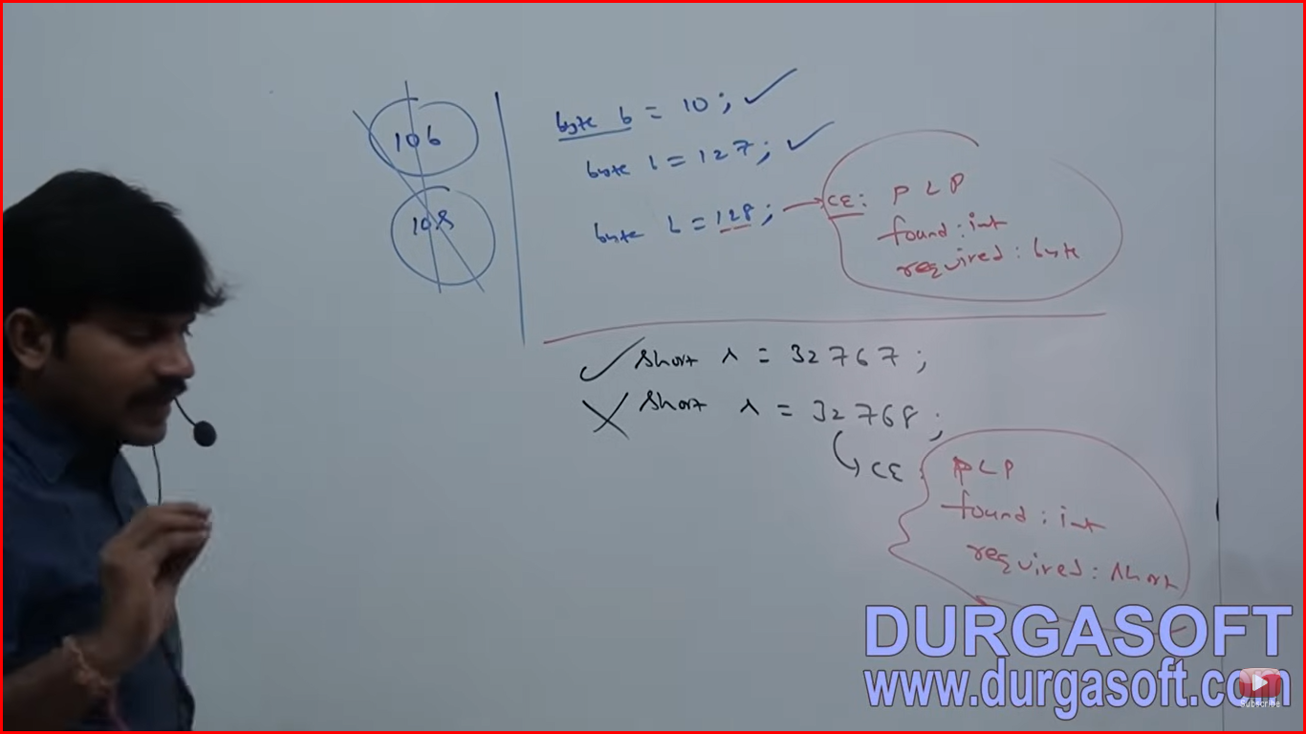

**Floating point Literals**

By default every floating point literal is of double type and hence we can’t assign directly to the float variable. But we can specify floating point literal as float type by suffixed with f or F.

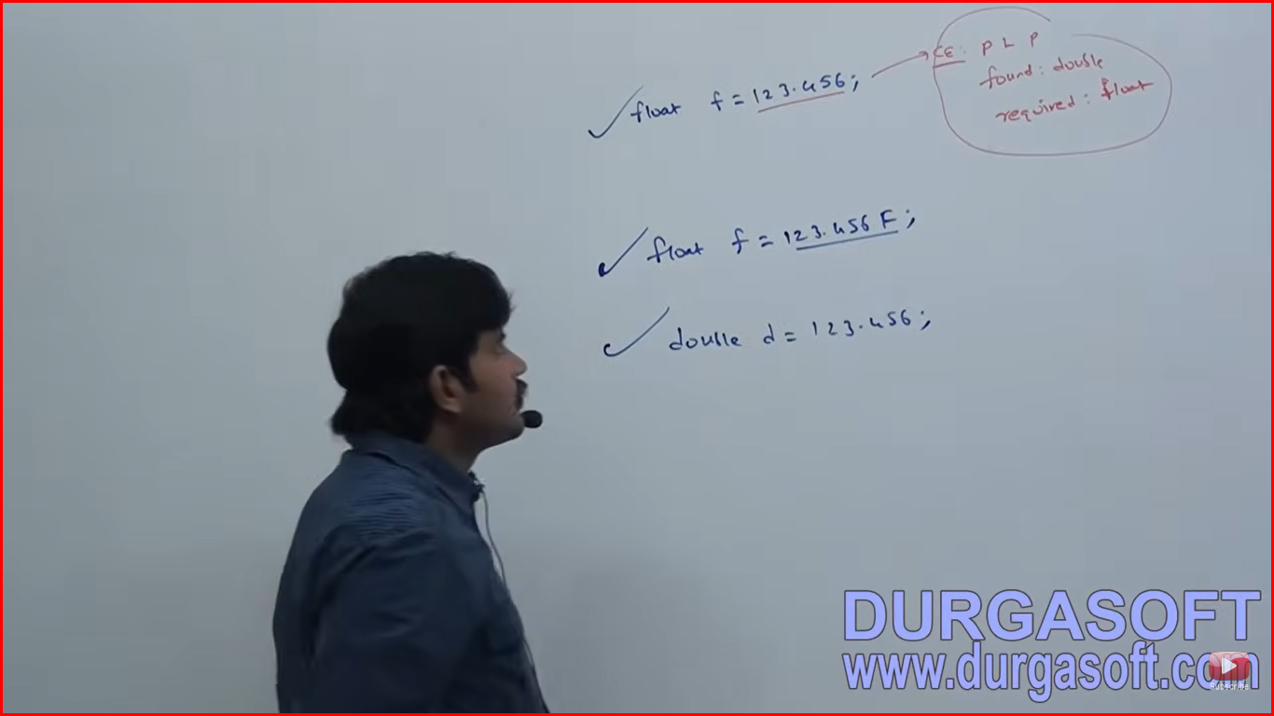

We can specify explicitly floating point type literal as double type by suffixed with d or D. Ofcourse this convention is not required.

**double d = 123.456d; //valid**

**float f = 123.456D; //invalid CE: PLP found double required float**

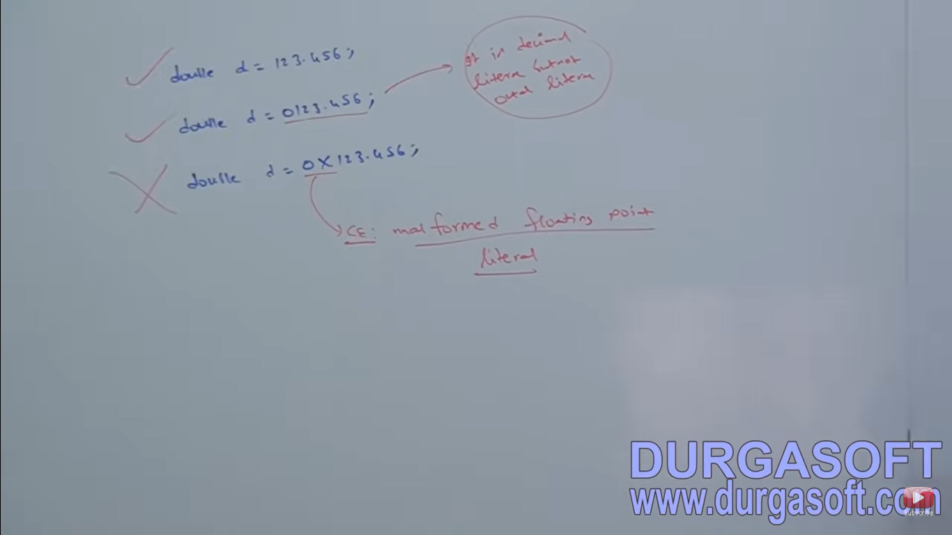

**We can specify floating point literals only in decimal form and we can’t specify in octal and hexadecimal forms.**

**double d2 = 123.456; //valid**

**double d3 = 0123.456; //valid**

**//double d4 = 0x123.456; //invalid CE: Malformed floating point literal**

**double d5 = 0786; //Invalid //Point is not there so it is treated as octal**

**double d6 = 0xFace; //valid answer - 64206.0**

**double d7 = 0786.0; //valid - answer 786.0**

**double d8 = 0XFace.0;//invalid CE: Malformed number**

**double d9 = 10; //valid answer 10.0**

**double df = 0777; //valid answer – 777.0**

**We can assign literal directly to floating point type variables and that integral literal can be specified either in decimal or octal or hexadecimal forms.**

**We can’t assign floating point literals to integral types.**

**double d =10; //valid**

**int x = 10.0;//inval CE:PLP found double but required int**

**double d = 1.2e3 //valid – answer - 1200.0**

**We can specify floating point literal even in exponential form (scientific notation)**

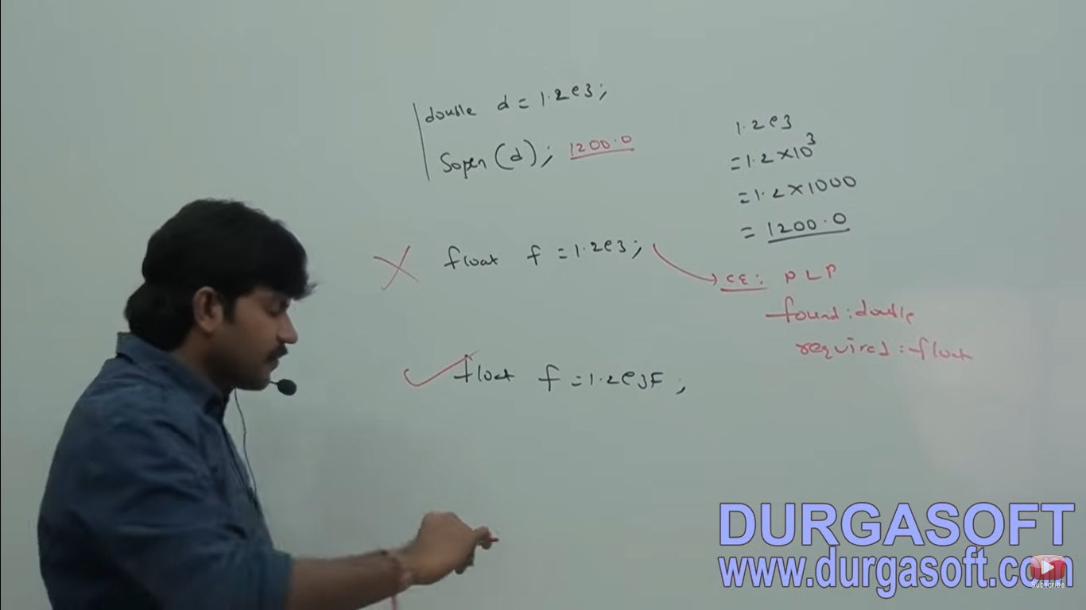

**Boolean data type**

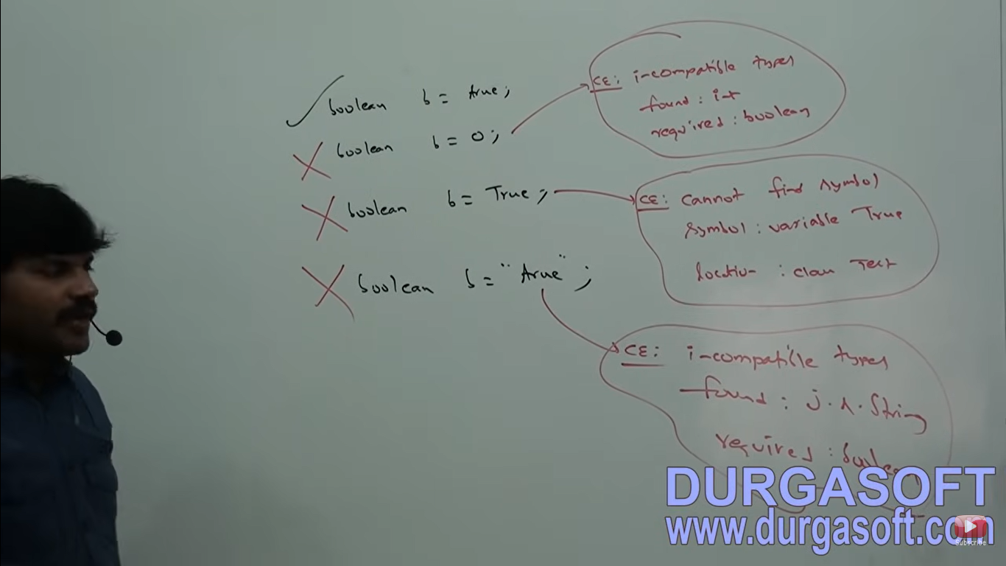

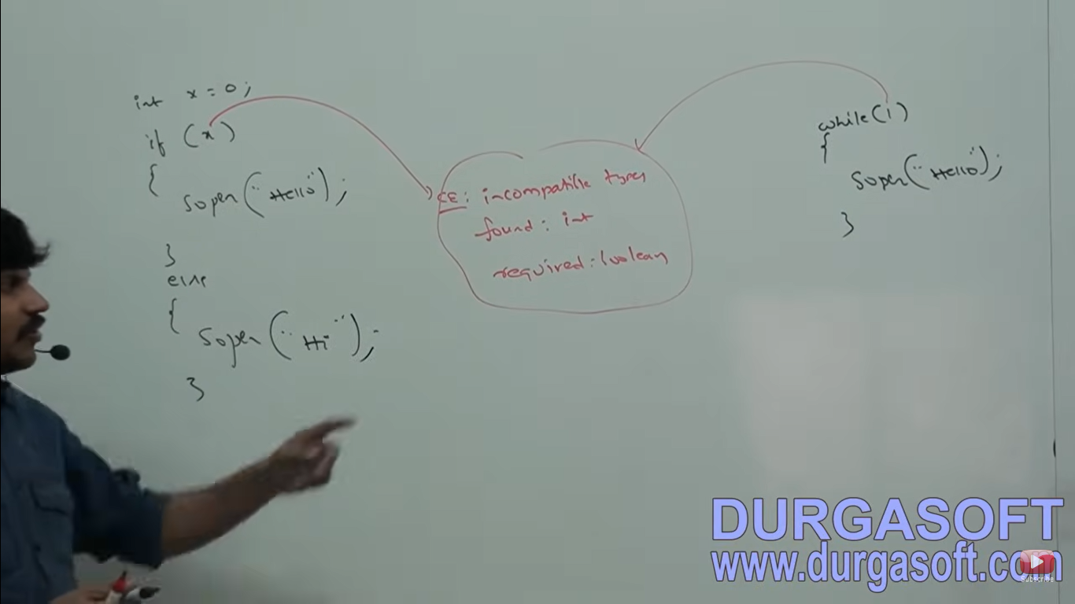

**Char Literals**

**We can specify char literal as single character within single quotes.**

**char ch = ‘a’; //valid**

**char ch = a; //invalid CE: cannot find symbol variable a in location class test**

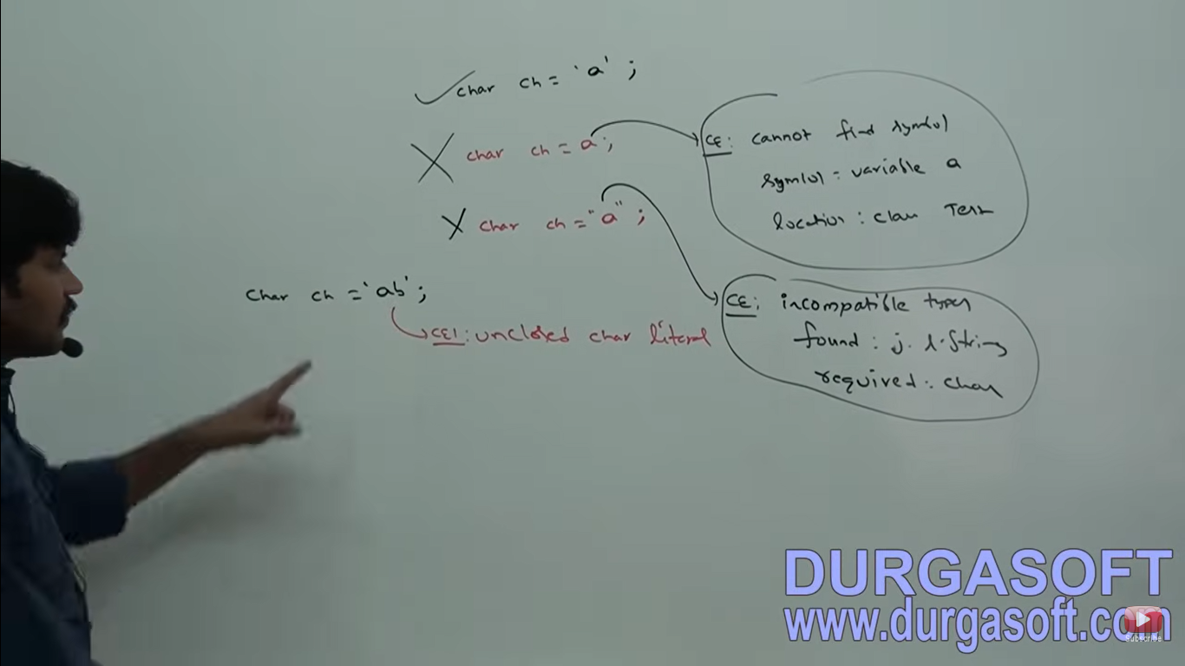

**We can specify char literal as integral literals which represents Unicode value of the character and that integral literal can be specified either in decimal or octal or hexadecimal forms but allowed range is 0 to 65535.**

**char ch4 = 97;**

**System.out.println(ch4);**

**char ch5 = 0XFace;**

**System.out.println(ch5); //valid**

**char ch6 = 65535;//valid**

**System.out.println(ch6);**

**//char ch7 = 65536; //invalid cannot convert from int to char**

**//System.out.println(ch7);**

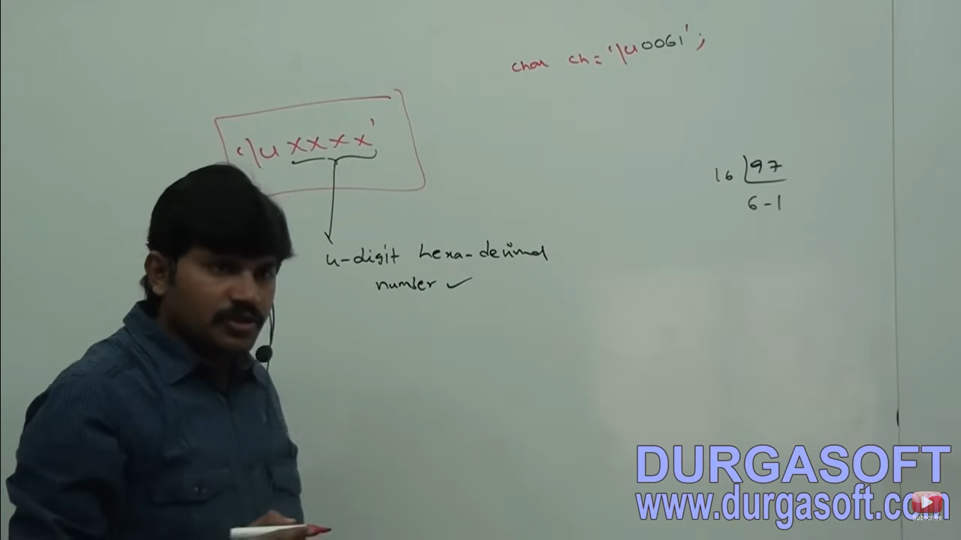

**We can represent har literal in Unicode representation which is nothing but ‘\uxxxx’**

**x – 4 digit hexadecimal number**

**For eg char ch = ‘\u0061’;**

**Sop(ch); //a**

**Every escape character is a valid char literal**

**Char ch = ‘\n’;**

**Char ch = ‘\t’;**

**Char ch = ‘\m’ //CE – IllegalEscapeCharacter**

**Escape character and Description:**

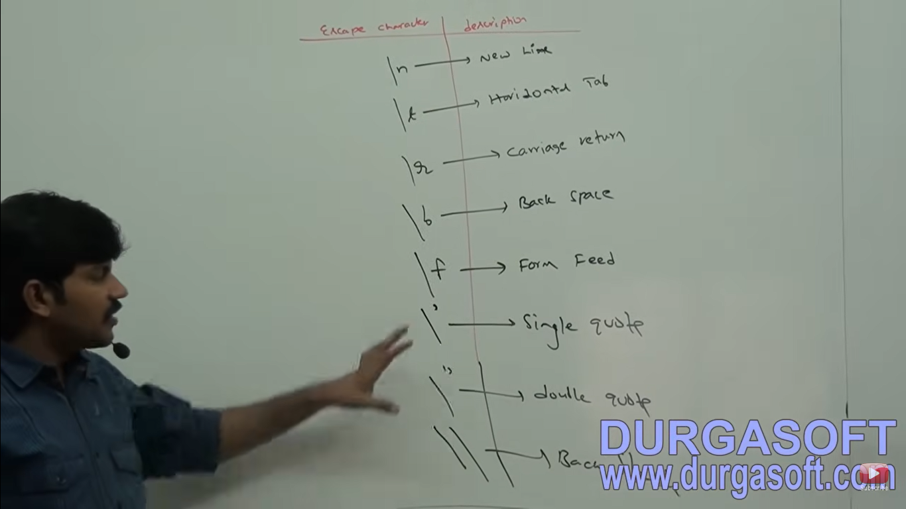

**Which of the following are valid?**

**Char ch = 65536; //invalid**

**Char ch = 0XBeer; //invalid because r is not valid**

**Char ch = \uface;//invalid single quotes missing**

**Char ch = ‘\ubeef’//valid – escape character**

**Char ch = ‘\m’//invalid - IllegalEscapeCharacter**

**Char ch = ‘\iface’; //invalid - \uface is valid but \iface invalid**

**String Literal**

Any sequence of characters within double quotes is treated as String literal. Eg. String s = “durga”;

**1.7v Enhancements with respect to literals**

1. **Binary Literals**

**int x = 0b1111;**

**sop(x); //15**

For Integral data types until 1.6v we can specify literal values in the following ways:

**I decimal**

**Ii Octal Form**

**Iii Hexadecimal form**

But from 1.7v onwards we can specify literal values even in binary form also. Allowed digits are 0 and 1. Literal value should be prefixed with 0b or oB.

From 1.7v onward we can use “_” symbol between digits of numeric literal. For eg:

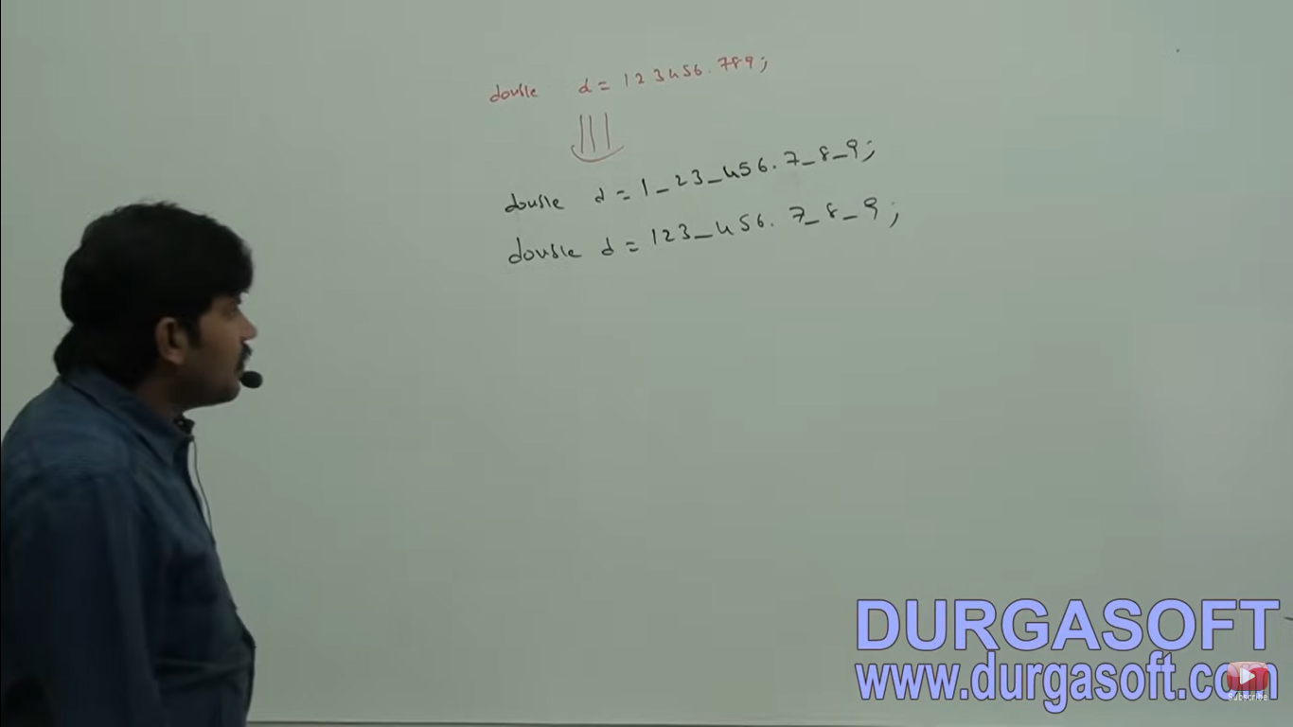

The main advantage of this approach is readability of the code will be improved.

At the time of compilation these underscore symbols will be removed automatically. Hence after compilation the above lines will become

d= 123_456.7_8_9;

double d = 12345.789

We can use more than one underscore symbols also between the digits

Double s = 1__23_4_5_6.7_8_9;



We can use underscore symbol only between the digits if w eare using anywhere else we will get compile time error

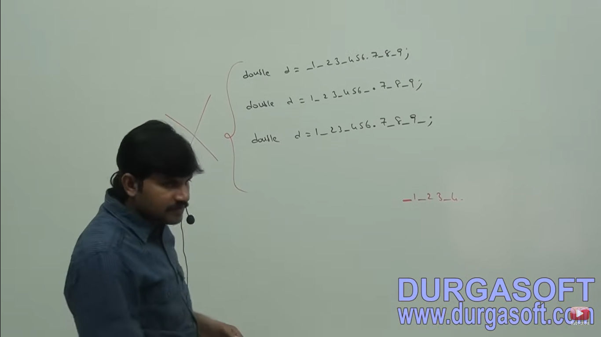

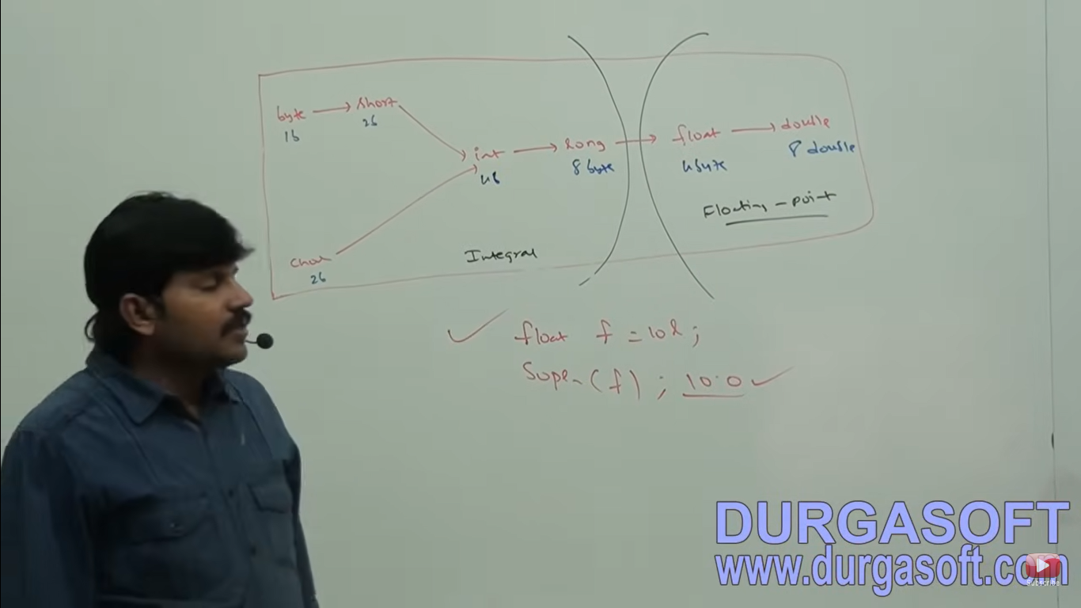

8 byte long value we can assign to 4 byte float variables because both are following different memory representation internally.

Float f = 10l;

Sop(f) //10.0